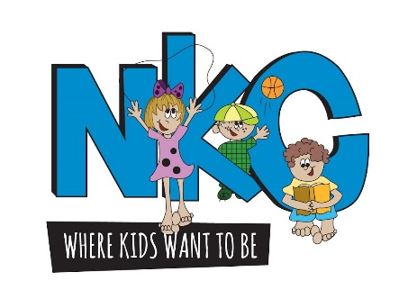

Neshaminy Kids Club
830 Town Center Drive, Suite 839, Langhorne, Pa, 19047

Application for the Casey Johnston Education Scholarship Awards

Eligibility:
Applicants must be graduating high school seniors from either Neshaminy High School or Bucks County Technical High School and majoring in field of education.
Qualifications:
To qualify for this award, you must include a record of community involved volunteerism demonstrated by a record of participation in a school, community, religious affiliation, or other settings.
Submit all application materials to the counseling office of your high school by Friday, April 14th, 2023.
Counselors should forward the applications to Neshaminy Kids Club, c/o Libby Caranci, 830 Town Center Drive, Suite 839, Langhorne Pa. 19047 or via email lcaranci@hotmail.com.
Emphasis will be placed on the community involved service to others and organizations and activities which you have participated.

Please print all information
Name: ______________________________________________________________________
Last First Middle
Address: ______________________________________________________________________
______________________________________________________________________
Telephone: _____________________________________________________________________

D.O.B ________________________ High School ______________________________________

Post-Secondary Institution Where You plan to use your scholarship award _________________________________________________________________________________

Proposed Field of Study _____________________________________________________________

Confirmed Acceptance _________ Yes _____________ No
Applicants Employment History: (Employee, Dates, Job Title)
*Attach additional sheets if needed
__________________________________________________
__________________________________________________
__________________________________________________
Service/Clubs:
______________________________________
______________________________________
______________________________________
Please write a brief statement why you are pursuing a degree in education. Also, share any community involved events or activities you participated within your school or community and how it impacted others. (Please attach or write in the space below)

Casey Johnston Educational Scholarship Award

Casey Johnston was a resident of Lower Southampton. She was a student at Temple University, where she was studying Community Development. Casey was a counselor at Neshaminy Kids Club. She loved her children, and co-workers. Casey had a positive impact on the children that crossed her path. Casey was truly admired by the children she took care of and their families. The kids rated Miss Casey as, “the best and coolest counselor ever”. Casey will be missed my many and she will certainly never be forgotten.
The Casey Johnston Education Scholarship Fund will be awarded to high school students attending Neshaminy High School and Bucks County Technical High School. Two $1000.00 scholarships will be awarded to two applicants pursuing to further their education at a two- or four-year college or university. Scholarship’s recipients will be notified by May 12, 2023.
*Applicants are due by April 14, 2023

